Gaurav Marmat
gmarmat@outlook.com | linkedin.com/in/gmarmat

Professional Summary
Director of Product Management with 10+ years of experience building and scaling software and IoT products in industrial and utility markets. Proven record of founding AI practices, driving new product introductions, commercializing enterprise licensing, and leading high-performing PM teams. Blends customer discovery, Lean/FBS methods, and monetization strategies to deliver measurable adoption, revenue growth, and market impact. Operate with FBS/LPM, KPI/OKR ownership, and commercialization rigor across industrial SaaS.
I am excited for Fortive’s FBSO/Growth Accelerator mandate to catalyze 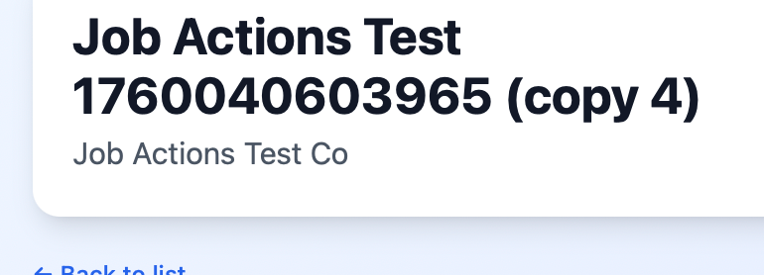AI products across OpCos.

Director of Product Management, Exceleron Dec’24 to present
Exceleron is a global fin-tech leader with products like bill payment processors, consumer portals, and customer information systems for the utilities industry. My responsibilities include:
- Founded Exceleron’s AI practice, leveraging utility customer base (20–50k citizens) as 'right to play' and domain expertise as 'right to win'. Launched inaugural AI product, securing 1 pilot (go-live Jan 2026) and 6 active design-partner engagements.
- Conducted strategy workshops to define principles, problems worth solving, and roadmaps; secured executive sponsorship and resources for a multi-year AI portfolio.
- Established KPI trees/OKRs (activation → adoption → attach) to track pilot and design-partner outcomes.
- Direct 4 Sr PMs, setting portfolio vision and driving cross-team execution to ensure scalable, monetizable modules for utilities software.
Sr Product Manager, Tektronix Feb’22 to Dec’24
Embraced FBS with excellence: Lead Policy Deployment workstreams, participated in many Kaizens, PSPs, and Product Management Bootcamps. Some of my key responsibilities:
- Spearheaded enterprise license model, delivering $1M pilot and influencing multi-product win-rates upward through pricing and packaging.
- Sponsored and launched OSS instrument-automation libraries (tm_devices, tekhsi, tm_data_types), driving 4% incremental hardware sales in 2 quarters.
- Led 120+ beta/VOC engagements, converting insights into roadmap updates and launch readiness, boosting adoption and reducing time-to-value.
- Repositioned offline analysis apps via UX redesign and telemetry, achieving +70% adoption and +50% revenue growth YoY with KPI/OKR cadences and tier reviews. Patent pending for waveform collaboration UX.
- Owned roadmap for Tek’s next gen software platform (microservices + event-driven architecture), accelerating go-to-market for hardware and enabling AI-assisted workflows.

Sr Product Manager, Gas Portfolio, Landis+Gyr Aug’18 to Feb’22
- Led NPI of smart IoT sensors for gas meters, extending lifecycle by 20 years and retiring 7M legacy endpoints with a 30% cost-optimized successor.
- Redefined field software tools with monetization and analytics, delivering 56% revenue growth and improved engineer productivity.
- Awarded 2 patents for IoT sensor field radios (USD1011305S1, D983762S).

Implementation Supervisor at Landis+Gyr, GA Jun’14 to Aug’18
- Recruited, developed, and managed implementation teams. Oversaw deployments of metering systems, driving customer adoption and satisfaction.

Skills
Software Platform Architecture, Scalable Systems Design, Cross-functional Leadership, API Integration, Agile Development (SAFe, Scrum, Kanban), Microservices, Security Best Practices, Strategic Planning, Product Monetization, UX/UI Optimization, FBS, Kaizen, PSP, Policy Deployment, DREAM, Lean Portfolio Management (LPM)

